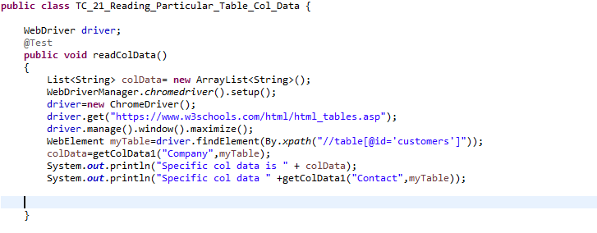

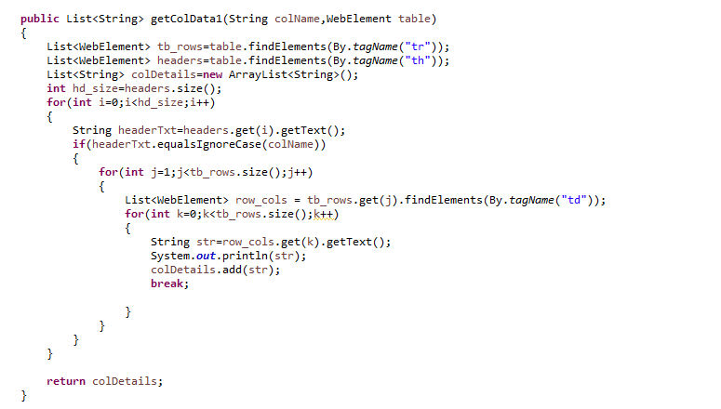

import java.util.ArrayList;

import java.util.List;

import org.openqa.selenium.By;

import org.openqa.selenium.WebDriver;

import org.openqa.selenium.WebElement;

import org.openqa.selenium.chrome.ChromeDriver;

import org.testng.annotations.AfterMethod;

import org.testng.annotations.Test;

import io.github.bonigarcia.wdm.WebDriverManager;

public class TC_21_Reading_Particular_Table_Col_Data {

WebDriver driver;

@Test

public void readColData()

{

List<String> colData= new ArrayList<String>();

WebDriverManager.chromedriver().setup();

driver=new ChromeDriver();

driver.get("https://www.w3schools.com/html/html_tables.asp");

driver.manage().window().maximize();

WebElement myTable=driver.findElement(By.xpath("//table[@id='customers']"));

colData=getColData1("Company",myTable);

System.out.println("Specific col data is " + colData);

System.out.println("Specific col data " +getColData1("Contact",myTable));

}

public List<String> getColData1(String colName,WebElement table)

{

List<WebElement> tb_rows=table.findElements(By.tagName("tr"));

List<WebElement> headers=table.findElements(By.tagName("th"));

List<String> colDetails=new ArrayList<String>();

int hd_size=headers.size();

for(int i=0;i<hd_size;i++)

{

String headerTxt=headers.get(i).getText();

if(headerTxt.equalsIgnoreCase(colName))

{

for(int j=1;j<tb_rows.size();j++)

{

List<WebElement> row_cols = tb_rows.get(j).findElements(By.tagName("td"));

for(int k=0;k<tb_rows.size();k++)

{

String str=row_cols.get(k).getText();

System.out.println(str);

colDetails.add(str);

break;

}

}

}

}

return colDetails;

}

@AfterMethod

public void quit()

{

driver.quit();

}

}